Annex I

Learning Agreement for studies – International Mobility

Erasmus+ Learning Agreement
Student Mobility for Studies
International Mobility

General information
Student | Last name(s) | First name(s) | Date of birth |  | Nationality* |  | Gender  [Male/Female/Undefined]
Student | ESI*, if applicable |  | Study cycle* |  | Field of education*  (ISCED) |  | Field of education  (clarification)
Sending Institution | Name | Faculty/Department |  | Erasmus code*/  City | Country | Administrative contact person name*; email; phone
Receiving Institution | Name | Faculty/Department |  | Erasmus code*/  City | Country | Administrative contact person name*; email; phone
The level of language competence* in ________ [indicate here the main language of instruction] that the student already has or agrees to acquire by the start of the study period is:
A1 ☐ A2 ☐ B1 ☐ B2 ☐ C1 ☐ C2 ☐ Native speaker ☐

Mobility type and duration
Mobility type (select one) | Estimated duration (to be confirmed by the Receiving Institution)
- Semester(s)* ☐ / Virtual component (only if applicable) ☐  - Blended mobility with short-term physical mobility* ☐  - Short-term doctoral mobility* ☐ / Virtual component (only if applicable) ☐ | Planned period of the physical mobility:  - from [day (optional)/month/year] …………….  - to [day (optional)/month/year] ……………
In case the mobility combines studies and traineeship, this template should be used and adjusted to fit both activity types.

Table A
Study Programme at the Receiving Institution (physical component of the mobility)
Component code*  (if any) | Component title (as indicated in the course catalogue*) or description of the study programme at the Receiving Institution | Semester, if applicable  [e.g. autumn/spring; term] | Number of ECTS credits* (or equivalent) to be awarded by the Receiving Institution upon successful completion
 |  |  | Total: …
Web link to the course catalogue at the Receiving Institution describing the learning outcomes: [web link to the relevant information]

Before the mobility
Table B
If applicable, description of the virtual component at Receiving Institution
Component  code (if any) | Component title or description of the study  programme at the Receiving Institution | Short description of the virtual component* | Number of ECTS credits (or equivalent) to be awarded by the Receiving Institution upon successful completion
 |  |  | Total: …

Table C
Recognition at the Sending Institution (physical and virtual components, if applicable)

Component code  (if any) | Component title (as indicated in the course catalogue) or description of the study programme at the Sending Institution | Semester, if applicable  [e.g. autumn/spring; term] | Number of ECTS credits (or equivalent) to be recognised by the Sending Institution | Automatic recognition*
 |  |  |  | Yes ☐ No ☐
 |  |  |  | Yes ☐ No ☐
 |  |  |  | Yes ☐ No ☐
 |  |  |  | Yes ☐ No ☐
 |  |  |  | Yes ☐ No ☐
 |  |  |  | Yes ☐ No ☐
 |  |  |  | Yes ☐ No ☐
 |  |  | Total: …
Provisions applying if the student does not complete successfully some educational components*: [web link to the relevant information]
Commitment of the three parties
By signing this document, the student, the Sending Institution and the Receiving Institution confirm that they approve the Learning Agreement and that they will comply with all the arrangements agreed by all parties. Sending and Receiving Institutions undertake to apply all the principles of the Erasmus Charter for Higher Education relating to mobility for studies (or the principles agreed in the Inter-Institutional Agreement for institutions located in third countries not associated to the Programme). The Beneficiary Institution and the student should also commit to what is set out in the Erasmus+ grant agreement. The Receiving Institution confirms that the educational components listed are in line with its course catalogue or as agreed otherwise and should be available to the student. The Sending Institution commits to recognise all the credits or equivalent units gained at the Receiving Institution for the successfully completed educational components and to count them towards the student's degree. The student and the Receiving Institution will communicate to the Sending Institution any problems or changes regarding the study programme, responsible persons and/or study period.
Commitment | Name | Email | Position | Date | Signature
Student |  |  | Student
Responsible person at the Sending Institution*
Responsible person at the Receiving Institution*

During the mobility

Table A2
Exceptional changes to Table A
(to be approved by the student, the responsible person in the Sending Institution and the responsible person in the Receiving Institution)
Component code  (if any) | Component title at the Receiving Institution  (as indicated in the course catalogue) | Deleted component  [tick if applicable] | Added component  [tick if applicable] | Reason for changing a component | Number of ECTS credits (or equivalent)
 |  | ☐ | ☐ | Choose an item.
 |  | ☐ | ☐ | Choose an item.
Table B2
Exceptional changes to Table B (if applicable)
(to be approved by the student, the responsible person in the Sending Institution and the responsible person in the Receiving Institution)
Component  code (if any) | Component title and/or description of the  Study programme at the Receiving  Institution | Deleted component  [tick if applicable] | Added component  [tick if applicable] | Reason for changing a component | Number of ECTS credits to be awarded
 |  | ☐ | ☐ | Choose an item. Choose an item.
 |  | ☐ | ☐ | Choose an item.

Table C2
Exceptional changes to Table C (if applicable)
(to be approved by the student and the responsible person in the Sending Institution)
 | Component code  (if any) | Component title at the Sending Institution  (as indicated in the course catalogue) | Deleted component  [tick if applicable] | Added component  [tick if applicable] | Reason for changing a component | Number of ECTS credits (or equivalent) | Automatic recognition
 |  |  | ☐ | ☐ | Choose an item. |  | Yes ☐ No ☐
 |  |  | ☐ | ☐ | Choose an item. |  | Yes ☐ No ☐

After the mobility
Table D
Transcript of Records at the Receiving Institution ( physical and virtual components, if applicable)
Start and end dates of the study period: from [day/month/year] ……………. to [day/month/year] …………….
Component code (if any) | Component title (as indicated in the course catalogue) catalogue) or description of the study  programme at the Receiving Institution | Was the component successfully completed by the student? | Number of ECTS credits (or equivalent) | Grades received at the Receiving Institution
 |  | Yes ☐ No ☐
 |  | Yes ☐ No ☐
 |  | Yes ☐ No ☐
 |  |  | Total: …

Table E
Transcript of Records and Recognition at the Sending Institution ( physical and virtual components, if applicable)
Component code (if any) | Component title (as indicated in the course catalogue) catalogue)  or description of the study programme at the Sending Institution | Number of ECTS credits (or equivalent) recognised | Grades received at the Receiving Institution
 |  | Total: …

Glossary

Term | Definition/Explanation
Nationality | Country to which the person belongs administratively and that issues the ID card and/or passport.
The European Student Identifier (ESI) | A unique European Identifier number used to identify and authenticate students using the Erasmus+ Mobile App and/or the desktop version of the app to fill in and sign their online learning agreement. If the sending institution does not issue an ESI for its students an alternative mechanism for identifying and authenticating students can be accepted. For more information, visit the Erasmus Without Paper Competence Centre.
Study cycle | Short cycle (EQF level 5) / Bachelor or equivalent first cycle (EQF level 6) / Master or equivalent second cycle (EQF level 7) / Doctorate or equivalent third cycle (EQF level 8).
Field of education | The ISCED-F 2013 search tool available at http://ec.europa.eu/education/international-standard-classification-of-education-isced_en should be used to find the ISCED 2013 detailed field of education and training that is closest to the subject of the degree to be awarded to the student by the Sending Institution.
Erasmus code | A unique identifier that every higher education institution that has been awarded with the Erasmus Charter for Higher Education (ECHE) receives. It is only applicable to higher education institutions located in EU Member States and third countries associated to the programme.
Administrative Contact person | A person who provides a link for administrative information and who, depending on the structure of the higher education institution, may be the departmental coordinator or works at the international relations office or equivalent body within the institution.
Mobility type: Semester(s) | A study period abroad lasting at least one academic term/trimester or 2 months to 12 months (long-term mobility)
Blended mobility | Any mobility can be carried out as a “blended mobility” by combining the study period abroad with on virtual component at the receiving institution before, during or after the physical mobility to further enhance the learning outcomes.
Short description of a virtual component | An indication of whether the virtual component is an online course(s), embedded in a course(s) selected at the receiving institution, embedded in a blended intensive programme and/or other type of online activity at the receiving institution along with component title(s) or short description of the online activity.
Blended mobility with short term physical mobility | If a long-term physical mobility is not suitable, the student may undertake a study period abroad lasting between 5 days and 30 days and combined with a compulsory virtual component to facilitate an online learning exchange and/or teamwork.
Short-term doctoral mobility | A study period abroad lasting between 5 days and 30 days. An optional virtual component to facilitate an online learning exchange and/or teamwork can be added to further enhance the learning outcomes.
ECTS credits (or equivalent) | In countries where the "ECTS" system is not in place, in particular for institutions located in third countries not associated to the programme not participating in the Bologna process, "ECTS" needs to be replaced in the relevant tables by the name of the equivalent system that is used, and a web link to an explanation to the system should be added.
Automatic recognition | All credits gained abroad– as agreed in the Learning Agreement and confirmed by the Transcript of Records – will be transferred without delay and counted towards the students' degree without any additional work or assessment of the student. This is signalled in the learning agreement by the “Yes” check box. If the “No” check box is selected, a clear justification needs to be provided and an indication on what other type of formal recognition will be applied e.g. registration in the students’ diploma supplement or Europass Mobility Document.
Educational component | A self-contained and formal structured learning experience that features learning outcomes, credits and forms of assessment. Examples of educational components are: a course, module, seminar, laboratory work, practical work, preparation/research for a thesis, mobility window or free electives.
Level of language competence | A description of the European Language Levels (CEFR) is available at: https://europass.cedefop.europa.eu/en/resources/european-language-levels-cefr
Course catalogue | Detailed, user-friendly and up-to-date information on the institution’s learning environment that should be available to students before the mobility period and throughout their studies to enable them to make the right choices and use their time most efficiently. The information concerns, for example, the qualifications offered, the learning, teaching and assessment procedures, the level of programmes, the individual educational components and the learning resources. The Course Catalogue should include the names of people to contact, with information about how, when and where to contact them.
Responsible person at the Sending Institution | An academic who has the authority to approve the Learning Agreement, to exceptionally amend it when it is needed, as well as to guarantee full recognition of such programme on behalf of the responsible academic body. The name and email of the Responsible person must be filled in only in case it differs from that of the Contact person mentioned at the top of the document.
Responsible person at the Receiving Institution | The name and email of the Responsible person must be filled in only in case it differs from that of the Contact person mentioned at the top of the document.
Reason for changing a component | - Previously selected educational component is not available at the Receiving Institution  - Component is in a different language than previously specified in the course catalogue  - Timetable conflict  - Substituting a deleted component  - Extending the mobility period  - Adding a virtual component  - Other (please specify)

Guidelines on how to use the
Erasmus+ Learning Agreement for Studies

The purpose of the Learning Agreement is to provide a transparent and efficient preparation of the study period abroad and to ensure that the student will receive recognition in his/her degree for the educational components successfully completed abroad.

This template is applicable to Erasmus+ mobility for studies between EU Member States or third countries associated to the programme and third countries not associated to the Programme (KA171). Under the Erasmus+ programme 2021-2027, higher Education Institutions must ensure the usage of digital learning agreements. Until this becomes available for international mobility, it is recommended to use this template. However, if higher education institutions already have an IT system in place to produce the Learning Agreement or the Transcript of Records, they can continue using it, provided that all the minimum requirements listed in this document are made available. Further fields can be added, if needed (e.g. information on the coordinator of a consortium), and the format (e.g. font size and colours) can be adapted.

General information

Administrative data

Before the mobility, it is necessary to fill in information on the student, the Sending and the Receiving Institutions in the general information table. The three parties have to agree on this section to be completed before the mobility. In case some administrative data is already available to the three parties the once-only principle can be applied, meaning there is no need to re-enter the data.

Following this, the student must select the type of mobility they plan to undertake and the estimated duration of their planned mobility. The student can select one the following mobility types:

- Semester(s): The student should select this mobility type if they are applying to undertake a long-term study mobility abroad with a duration from 2 months to 12 months. The student also has the option to add a virtual component to their study mobility before, during or after. If the student uses this option, they must also select the virtual component as part of their mobility type.
- Blended mobility with short-term physical mobility: The student should select this mobility type if they are applying to undertake a short-term physical mobility abroad of 5-30 days by combining it with a compulsory virtual component.
- Short-term doctoral mobility: Doctoral Candidates should select this mobility type when they are applying to undertake a short-term physical mobility of 5-30 days. The Doctoral candidate also has the option to add a virtual component to their study mobility before, during or after. If the student uses this option, they must also select the virtual component as part of their mobility type.
In addition to selecting the mobility type, the learning agreement should also include the indicative start and end date of the agreed study programme that the student will carry out abroad. In the case of a study mobility abroad with a duration from 2 months to 12 months, the indicative month/year is sufficient. Most of the general information fields related to the student, Sending and Receiving Institutions and planned mobility will have to be reported in the Beneficiary Module by the beneficiary, once the internal selection procedures are completed and the mobility grants are awarded.

Before the mobility

Educational components (Tables A, B and C)

The Learning Agreement must include all the educational components to be carried out by the student at the Receiving Institution during their physical mobility (in Table A) or as virtual component of the mobility (in Table B) and it must contain as well the group of educational components that will be replaced in his/her degree by the Sending Institution (in Table C) upon successful completion of the study programme abroad. It is necessary to fill in Tables A, B (if applicable) and C thoroughly before the mobility. Additional rows and columns can be added as needed. However, the tables must be kept separated. The objective is to make clear that there is no need to have one-to-one correspondence between the components followed abroad and the ones replaced at the Sending Institution. The aim is rather that a group of learning outcomes achieved abroad replaces a group of learning outcomes at the Sending Institution.

In countries belonging to the European Higher Education Area (EHEA) an academic year of full-time study is normally made up of educational components totalling 60 ECTS credits. It is recommended that for mobility periods shorter than a full academic year, the educational components selected should equate to a roughly proportionate number of credits (or equivalent units in countries outside the EHEA). In case the student follows additional educational components beyond those required for his/her degree programme, these additional credits (or equivalent) must also be listed in the study programme outlined in Table A.

In case of thesis research/doctoral work at the receiving institution, the component "Thesis research" or "Doctoral work" will be included in Table A. If no ECTS credits are provided by the receiving institution, it is sufficient to write "not applicable" in that column. The thesis/doctoral work and the associated workload in ECTS credits will be included in Table C, if relevant for the sending institution.

If the student has chosen to add a virtual component offered by the receiving institution to their study mobility that will award ECTS credits (or equivalent), Table B should also be included in the Learning Agreement. The purpose is to give the student the possibility to enhance further the learning outcomes of the mobility period abroad by complementing the physical component with online learning, training or teamwork. When relevant, Table B must include a title or description of the educational component in addition to a short description of the nature of the virtual component e.g. online course, online cultural preparation with other exchange students or online training with a teacher. In the same table, the sending institution will indicate how the ECTS credits (or equivalent) of the added virtual component will be recognised. If no virtual component is foreseen, Table B could be either kept blank or removed (renaming of the tables will be needed).

The Sending Institution should indicate in Table C the group of educational components counting towards the student’s degree that would normally be completed at the Sending Institution and which will be replaced by the Study Programme at the Receiving Institution. The total number of ECTS credits (or equivalent) in Table C should correspond to the total number of ECTS credits (or equivalent) contained in Table A and B. Any exception to this rule should be clearly stated in an annex of the Learning Agreement and agreed by all parties. Example of justification for a discrepancy in the total number of ECTS credits (or equivalent) between Table A/B and Table C: the student has already accumulated the number of credits required for his/her degree and does not need some of the credits gained abroad.

Practical examples of how to fill in the tables provided in the Learning Agreement

The student must include all the educational components to be carried out at the Receiving Institution during their physical mobility (in Table A) or as virtual component of the mobility (in Table B) i.e. information about the selected courses or modules as indicated in the course catalogue, laboratory or thesis work, participation in webinars, etc. The group of components can then be included in Table C as follows:

Table C
Recognition at the Sending Institution (physical and virtual components, if applicable)

Component code  (if any) | Component title (as indicated in the course catalogue) or description of the study programme at the Sending Institution | Semester, if applicable  [e.g. autumn/spring; term] | Number of ECTS credits (or equivalent) to be recognised by the Sending Institution | Automatic recognition*
 | Course X | Autumn | 6 | Yes ☒ No ☐
 | Module Y | Spring | 10 | Yes ☒ No ☐
 | Laboratory Work | … | 8 | Yes ☒ No ☐
 | Thesis research/Doctoral work | … | 10 | Yes ☒ No ☐
 | Blended Intensive Programme X: online workshop and presentation | … | 5 | Yes ☒ No ☐
 | Doctoral work: participation in webinar | … | “not applicable” | Yes ☒ No ☐
 |  |  | Total: 39
Provisions applying if the student does not complete successfully some educational components*: [web link to the relevant information]

In table C, the check box “Yes” for Automatic Recognition means that the sending institutions confirms that all credits gained abroad – as agreed in the Learning Agreement and confirmed by the Transcript of Records – will be transferred without delay and counted towards the students' degree without any additional work or assessment of the student. The “No” check box means that a clear justification needs to be provided and an indication on what other type of formal recognition will be applied e.g. registration in the students’ diploma supplement or Europass Mobility Document.
The European Commission encourages institutions also to embed mobility windows in their curricula. Where all credits in Table A and B are automatically recognised as forming part of the programme at the Sending Institution, typically in the case of mobility windows, Table C is simplified and reduced to one single line, as described below:
Table C
Recognition at the Sending Institution (physical and virtual components, if applicable)

Component code  (if any) | Component title (as indicated in the course catalogue) or description of the study programme at the Sending Institution | Semester, if applicable  [e.g. autumn/spring; term] | Number of ECTS credits (or equivalent) to be recognised by the Sending Institution | Automatic recognition*
 | Mobility Window | Autumn | 30 | Yes ☒ No ☐
 |  |  | Total: 30
Provisions applying if the student does not complete successfully some educational components*: [web link to the relevant information]

If an educational component covers both physical and virtual periods of the mobility, its description might differ and therefore be inserted separately in Tables A and B. However, each title should remain the same and the ECTS to be awarded should be inserted only once either in Table A or B.
The Sending Institution must foresee which provisions will apply if the student does not successfully complete some of the educational components from his study programme abroad, by providing a web link in the relevant data field.

Language competence

A recommended level in the main language of instruction has been agreed between the Sending and Receiving Institutions in their Inter-Institutional Agreement. The Sending Institution is responsible for providing support to its selected candidates so that they can have the recommended language skills at the start of the study period.

The level of language competence in the main language of instruction, which the student already has or agrees to acquire by the start of the study period, has to be reported in the box provided for that purpose in the Learning Agreement for Studies or, alternatively, in the grant agreement.

In case the level of the selected student is below the recommended one when signing the Learning Agreement (or grant agreement), the Sending Institution and the student should agree that he/she will reach the recommended level by the start of the mobility. They should also discuss and decide the type of support to be provided to the student by the Sending or Receiving Institution. The Erasmus+ Online Language Support (OLS) has been designed to assist Erasmus+ students in improving their knowledge of the main language of instruction, before and during their stay abroad, to ensure a better quality of learning mobility.
For mobility of 14 days or more, the student must carry out an OLS language assessment in the language of mobility, if available on OLS, before the mobility, except for native speakers and in duly justified cases. The completion of the OLS assessment before departure is a pre-requisite for the mobility. This assessment will be taken after the student is selected, before signing the Learning Agreement or, alternatively, the grant agreement. All mobility participants have the opportunity to follow courses in the language(s) of their choice, available on the OLS platform.

Signing the Learning Agreement

All parties must sign the Learning Agreement before the start of the mobility. It is not compulsory to circulate papers with original signatures; scanned copies of signatures or digital signatures may be accepted, depending on the national legislation or institutional regulations.

During the mobility

Exceptional Changes to the Study Programme (Table A2, B2 and C2)

Changes to the study programme should be exceptional, as the three parties have already agreed on a group of educational components that will be taken abroad, based on the course catalogue that the Receiving Institution has committed to publish well in advance of the mobility period and to update regularly. Any party can signal the need for changes to the study programme and the student can initiate the changes within five weeks after the start of each semester. These changes should be agreed by all parties as soon as possible, within two-weeks following the request.

In case of changes due to an extension of the duration of the mobility, a request can be made by the student at the latest one month before the foreseen end date.

All changes should be indicated in Tables A2, B2 and C2 (when applicable), while Tables A, B and C should not be modified. All Tables (A, B, C, A2, B2 and C2) should be kept together in all communications. In case of changes, please choose the appropriate reason from the drop-down list.

Confirming the Changes
All parties must approve the changes to the Learning Agreement. The European Commission would like to limit the use of paper for exchanging documents and it is therefore accepted to exchange information electronically, e.g. via email, scanned or digital signatures, etc. without the need of a paper signature. However, if national legislations or institutional regulations require paper signatures, a signature box should be added where needed.

After the mobility

Transcript of Records at the Receiving Institution (Table D)

After the mobility, the Receiving Institution should send a Transcript of Records to the student and to the Sending Institution within a period stipulated in the Digital Inter-Institutional Agreement (normally within five weeks after publication/proclamation of the student’s results at the Receiving Institution). It can be provided electronically or through any other means accessible to the student and the Sending Institution. The Transcript of Records from the Receiving Institution should refer to the educational components agreed in Table A, and where applicable B, as well as in Tables A2 and B2 where applicable. Grade distribution information should be included (web link or annex).

The actual start and end dates of the study period should be included according to the following definitions:

The start date of the study period is the first day the student has been present at the Receiving Institution. For example, this could be the start date of the first course, a welcoming event organised by the Receiving Institution, an information session for students with fewer opportunities, a language and intercultural course organised either by the Receiving Institution or other organisations (if the Sending Institution considers it relevant for the mobility).

The end date of the study period is the last day the student had to be present at the Receiving Institution, not his actual date of departure. This is, for example, the end of exams period, courses or mandatory sitting period.

Transcript of Records and Recognition at the Sending Institution (Table E)

Following the receipt of the Transcript of Records from the Receiving Institution, the Sending Institution should recognise automatically the student’s academic outcomes successfully completed at the Receiving Institution. The Sending Institution should fully recognise the total number of ECTS credits (or equivalent) contained in Table C (and if applicable, B, B2 and C2).
Where applicable, the Sending Institution will convert the grades received by the student abroad, taking into account the grade distribution information from the Receiving Institution (see the methodology described in the ECTS Users' Guide). The European Commission encourages institutions to use the EGRACONS tool for this purpose.
The Sending Institution will provide a Transcript of Records (Table E) to the student or record the results in a database or any other means accessible to the student, normally within five weeks after having received the transcript of the Receiving Institution. The student will be able to report on the recognition by the Sending Institution via the on-line EU survey or a complementary online survey.
Diploma Supplement: The information contained in the Transcript of Records from the Receiving Institution should also be included in the Diploma Supplement produced by the Sending Institution (at least for Sending Institutions located in EU Member States or associated third countries) with the exact titles of the components that the student has followed abroad.

Annex II

General Conditions

Annex II

GENERAL CONDITIONS

Article 1: Liability
Each party of this agreement shall exonerate the other from any civil liability for damages suffered by them or their staff as a result of performance of this agreement, provided such damages are not the result of serious and deliberate misconduct on the part of the other party or his staff.
The National Agency of Portugal, the European Commission or their staff shall not be held liable in the event of a claim under the agreement relating to any damage caused during the execution of the mobility period. Consequently, the National Agency of Portugal or the European Commission shall not entertain any request for indemnity of reimbursement accompanying such claim.

Article 2: Termination of the agreement
In the event of failure by the participant to perform any of the obligations arising from the agreement, and regardless of the consequences provided for under the applicable law, the organisation is legally entitled to terminate or cancel the agreement without any further legal formality where no action is taken by the participant within one month of receiving notification by registered letter.
If the participant terminates the agreement before its agreement ends or if they fail to follow the agreement in accordance with the rules, they shall have to refund the amount of the grant already paid, except if agreed differently with the sending organisation.
In case of termination by the participant due to "force majeure", i.e. an unforeseeable exceptional situation or event beyond the participant's control and not attributable to error or negligence on their part, the participant shall be entitled to receive at least the amount of the grant corresponding to the actual duration of the mobility period. Any remaining funds shall have to be refunded.

Article 3: Data Protection
All personal data contained in the agreement shall be processed in accordance with Regulation (EC) No 2018/1725 of the European Parliament and of the Council on the protection of individuals with regard to the processing of personal data by the EU institutions and bodies and on the free movement of such data. Such data shall be processed solely in connection with the implementation and follow-up of the agreement by the sending organisation, the National Agency and the European Commission, without prejudice to the possibility of passing the data to the bodies responsible for inspection and audit in accordance with EU legislation (Court of Auditors or European Antifraud Office (OLAF)).
The participant may, on written request, gain access to their personal data and correct any information that is inaccurate or incomplete. They should address any questions regarding the processing of their personal data to the sending organisation and/or the National Agency. The participant may lodge a complaint against the processing of their personal data to the European Data Protection Supervisor with regard to the use of the data by the European Commission.

Article 4: Checks and Audits
The parties of the agreement undertake to provide any detailed information requested by the European Commission, the National Agency of Portugal or by any other outside body authorised by the European Commission or the National Agency of Portugal to check that the mobility period and the provisions of the agreement are being properly implemented.

Annex III

Erasmus Student Charter

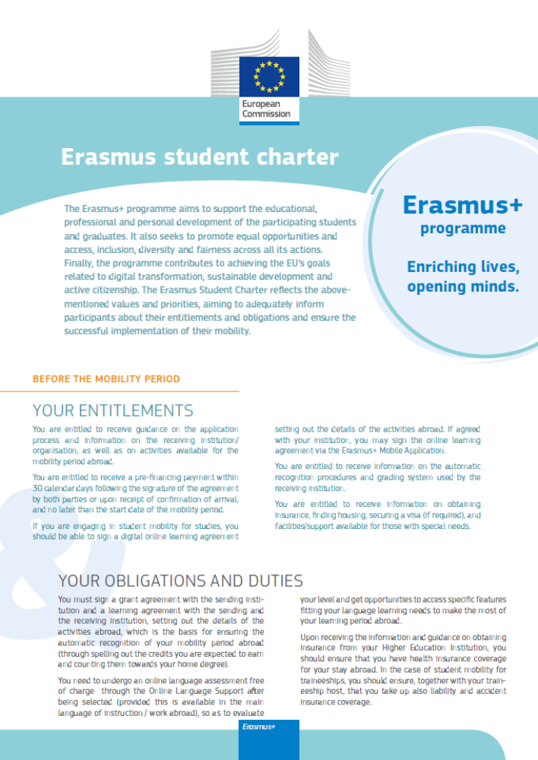
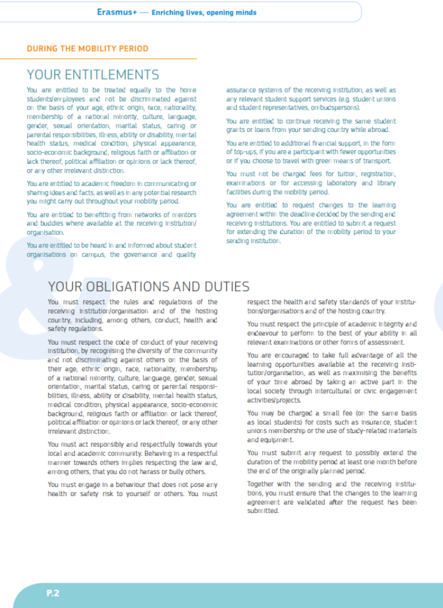

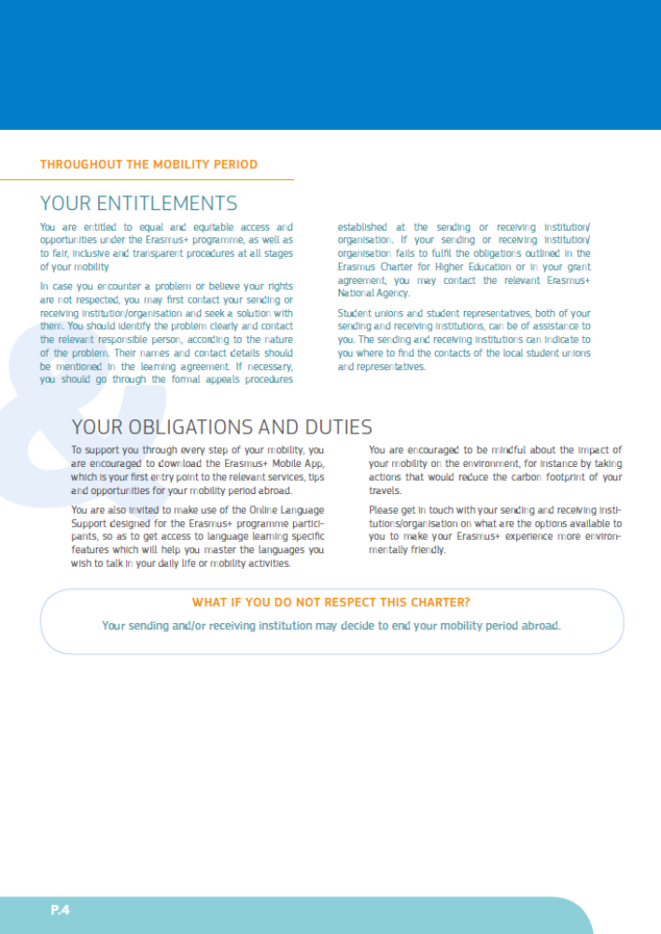

Additional information on the purpose of processing your personal data, what data we collect, who has access to it and how it is protected, can be found at: https://webgate.ec.europa.eu/erasmus-esc/index/privacy-statement

